**Submission Name**: WIN - When in Need

**Short Description**: WIN is an information intake tool to channel healthcare resources

**Long Description:**

WIN - When In Need is an information intake tool from Make-A-Difference (M-A-D) team. As part of the Call for Code program we are proposing a tool that will collate information needed to channel health and wellness resources. This will address the end problem of healthcare resource shortage.

During Disaster: It is often found in time of natural disasters such as earthquakes, floods, hurricanes, once people start assembling in relief camps or safe zones, there is a need to manage people’s food, sanitation and healthcare needs however it is challenging to estimate the needed quantities. Resources – food, medicines and healthcare personnel – are limited. It is essential to address people based on their exposure or vulnerability to health risks to better utilize available people and stock.

While there are certain situations that naturally require priority redressal such as expectant mothers, children, differently abled, WIN is a tool that enables non-healthcare professionals to collect information about affected persons by a natural disaster who might not manifest obvious risks or vulnerabilities. WIN guides the person, a volunteer in this case, through the process of collecting essential health and well-being information from occupants in the relief camp.

Keeping in mind that internet connectivity or phone lines might be disrupted, WIN provides a dual interface to enable information collection using either a chatbot or an IVR feature. Both channels enable collection of the same information.

The information thus collected is sent to a central server which is meant to process this information and derive the amount of resources needed and identify people who seem to need it first. This could mean the following:

* Directing healthcare professionals present on-site to the set of people in need. It also helps assess if more personnel will be needed at the relief site
* Ensuring required medicines are in stock at the camp site or initiate provisioning of needed medicines per estimated quantities

Here’s a schematic of the above:

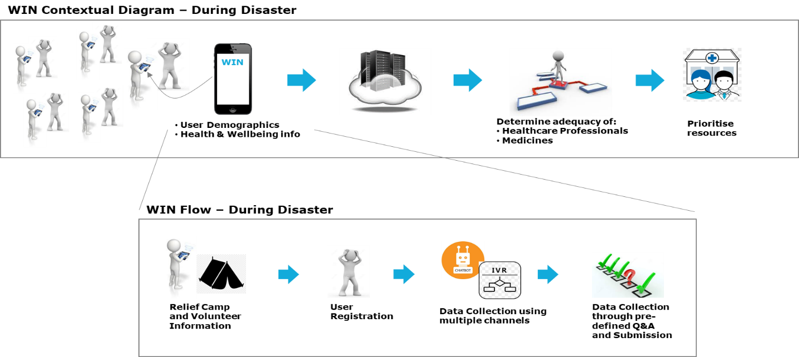

Post Disaster: An added feature of WIN is for use after the natural calamity. It helps people assess the structural stability of their homes when they are ready to return. The person is expected to click photos of their home from all possible sides they can using WIN. They will be given an indication of whether the structure is safe to inhabit. This is needed when floods, cyclone or earthquake has hit this area. The same assessment can be done for neighbouring structures as well.

In summary, the scope of WIN can be summarised as follows:

* Features: Data Collection (during disaster), Structural Stability assessment (post disaster)
* Natural Disasters: Floods, Cyclones, Earthquake
* Geography: India
* Diseases: Cholera, Vector-borne diseases
* User: Volunteers

Here’s a schematic of the post disaster feature:

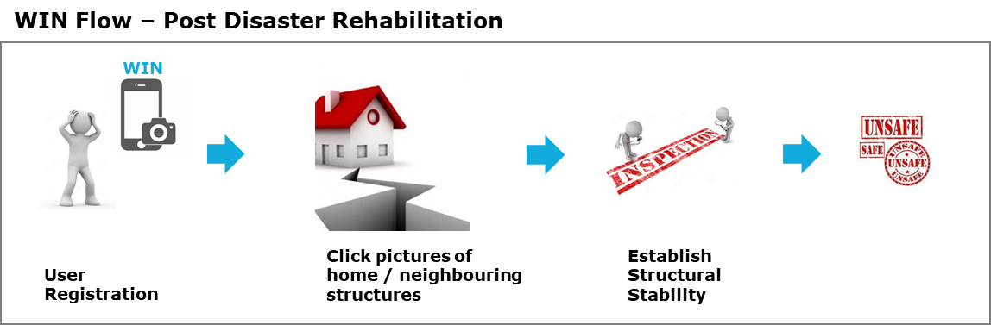

Assumptions

* Volunteers are proficient in operating smartphones and apps
* There is one of either internet connectivity or telephone connectivity available
* There is an initial set of people and inventory of resources available at the relief camp

**Solution Roadmap**:

WIN includes two features presently:

1. **Data collection**

The data collected presently is related to symptoms of cholera and vector borne diseases. This feature is to be extended with using Machine Learning algorithms to assess probability of the above disease. Given a dataset of newly fed information, an assessment of resources needed is to be derived using the probability data.

While the above addresses a single relief camp scenario, it is to be expanded to cover multiple relief camps during a disaster so that re-distribution of limited resources between camps can be enabled.

In addition to the above, disease diagnosis feature can be leveraged by a healthcare professional, or facility, outside the natural calamity situation as well.

1. **Structural Stability assessment**

The structural stability feature can be used as is, anytime, during and after disasters. While existing assessment is a generic in nature, following is a probable next step:

* Include assessment of structural damages, specific to calamities, for better results
* Include classification of structure into home, office spaces, warehouse or more to assess risk and stability aligned to its use